**PROJECT PLANNING PHASE**

**MILESTONE & ACTIVITY LIST**

DATE

TEAM ID

PROJECT NAME

AI

-

powered Nutrition Analyzer for Fitness Enthusiasts

**Milestone:**

Intelligences (AI) Model.

T

o build

a model which is used for classifying the fruit depends on

the different characteristics like colour, shape, texture etc. Here the user can capture the

images of different fruits and then the image will be sent the trained model. The model

anal

yses the image and detect the nutrition based on the fruits like (Sugar, Fibre, Protein,

Calories, etc.)

.

**Activity List:**

In Project Management Planning is an Important task to scheduling the phrase of the project

to the Team Member. In this Activity can shows the various activity are allocated and Done

by the Team Members! In Project we can Split into the Four Step of Phrase

s are

Phrase 1: Information Collection and Requirement Analysis.

Phrase 2: Project Planning and Developing Modules.

Phrase 3: Implementing the High Accuracy Deep Learning Algorithm to Perform.

Phrase 4: Deploying the Model on Cloud and Testing the Model

and UI Performance

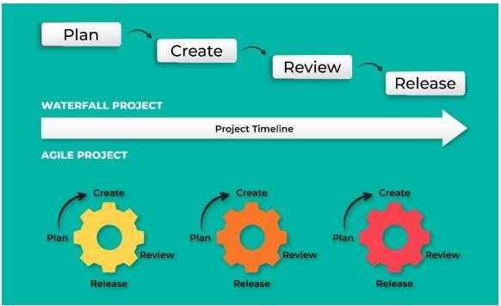

2022

November

18

PNT2022TMID39001

Modern Technology are increasing and optimizing the Performance of the Artificial